When trying to log in, if the user type is not specified, an exception message will be toasted.

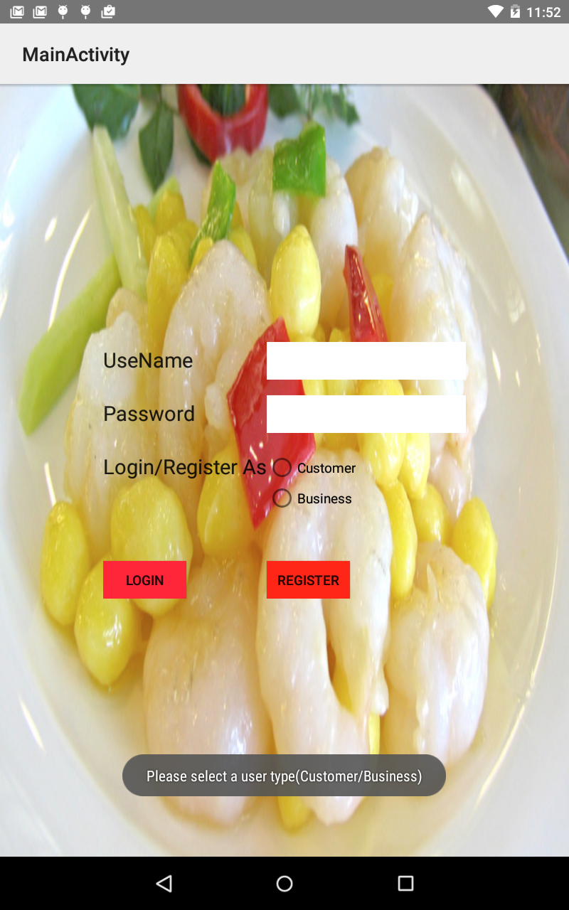

If invalid login information is provided, an exception message will also be toasted.

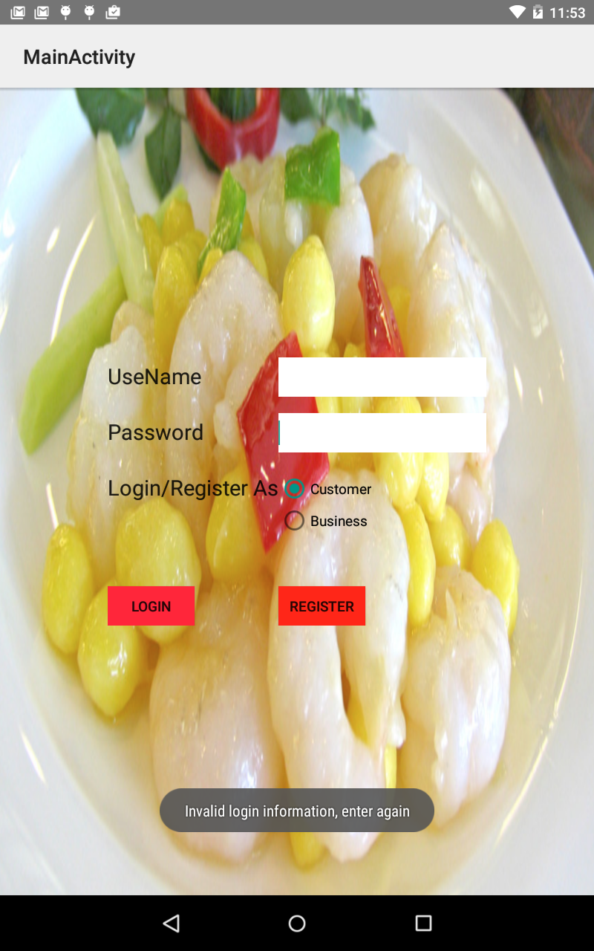

If the customer deleted the rating in a wrong order of operation, an exception message will be posted showing the right order.

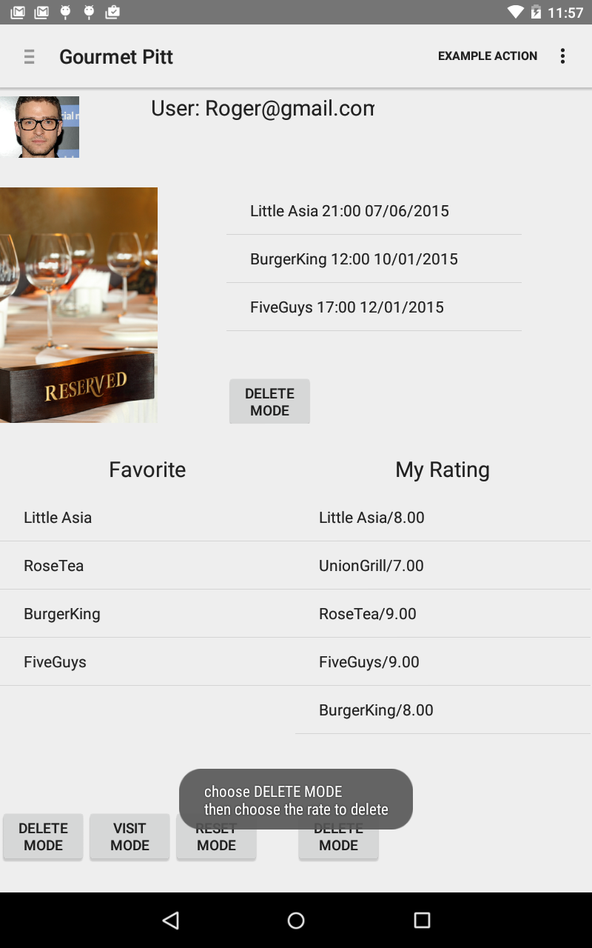

Similar, if the reservation is deleted in the wrong order, similar information will be toasted.

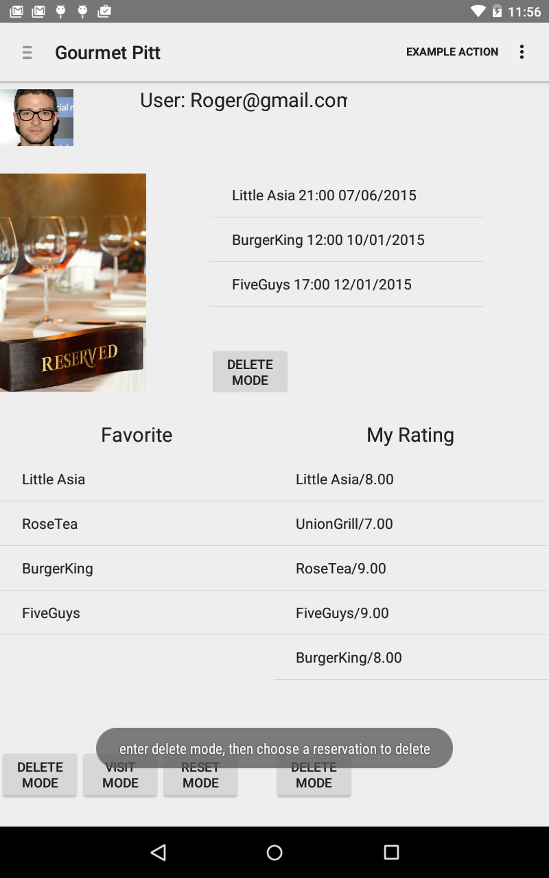

When the customer tries to rate and review a restaurant. Exception will be thrown if rating is negative or empty or greater than 10.

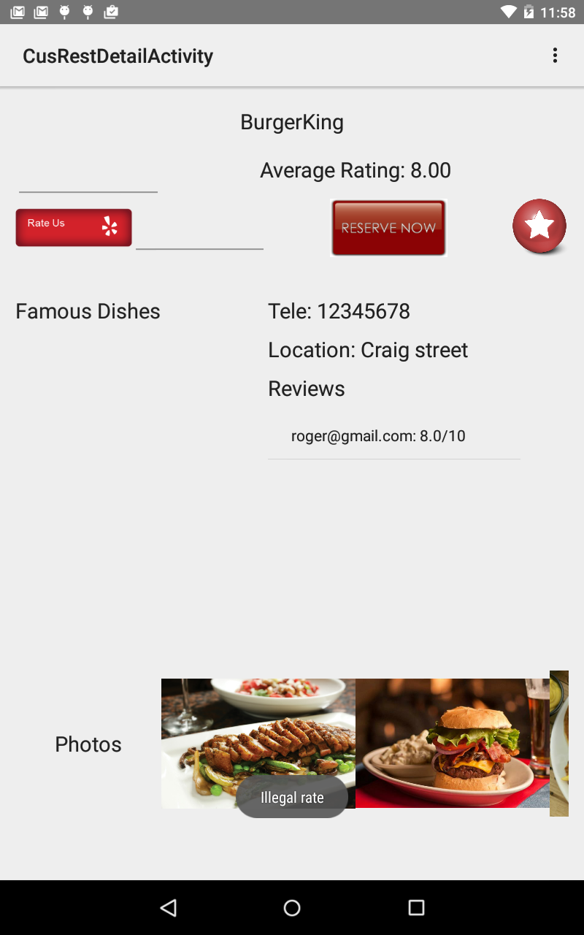

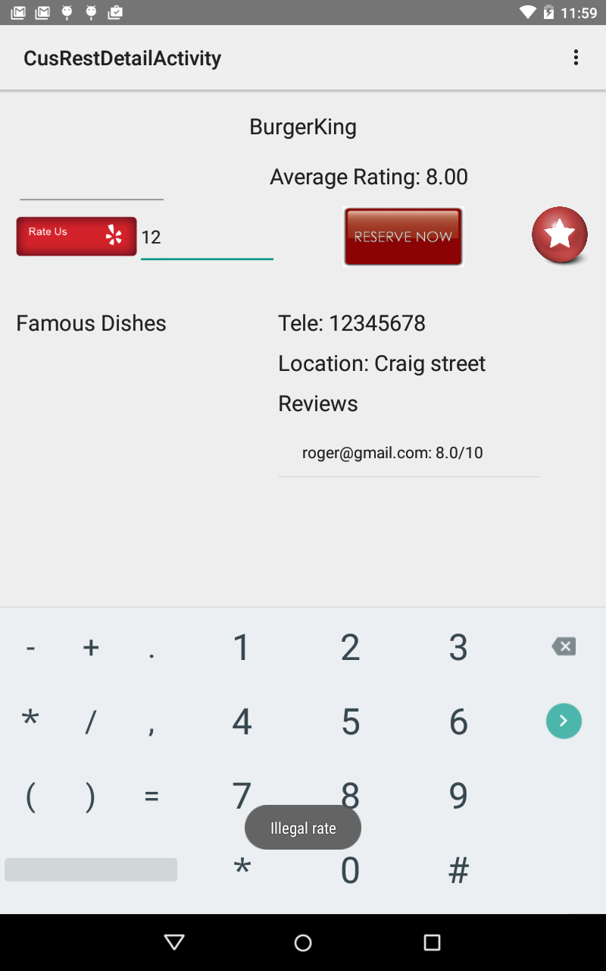

When making a reservation, if the user’s reservation time does not abide by the time format is not hour : minute or the date is not month/day/year, an exception message will be toasted showing the right format.

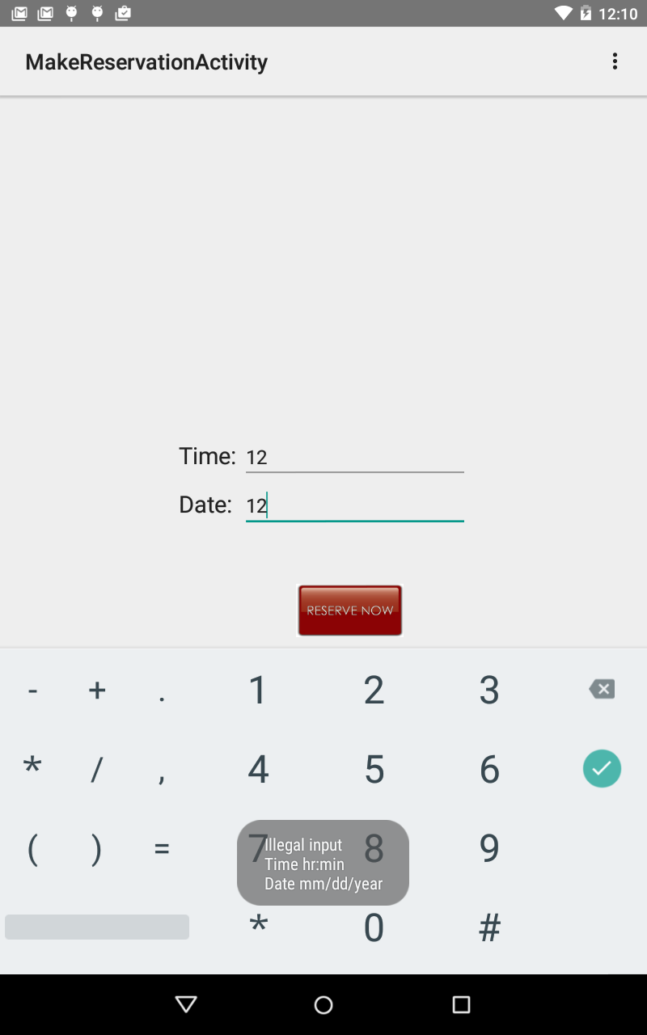

Business:

When creating a new restaurant, all the fields for restaurant information can not be left empty. Otherwise, an exception will be thrown out and the exception will be written to the log file on device.

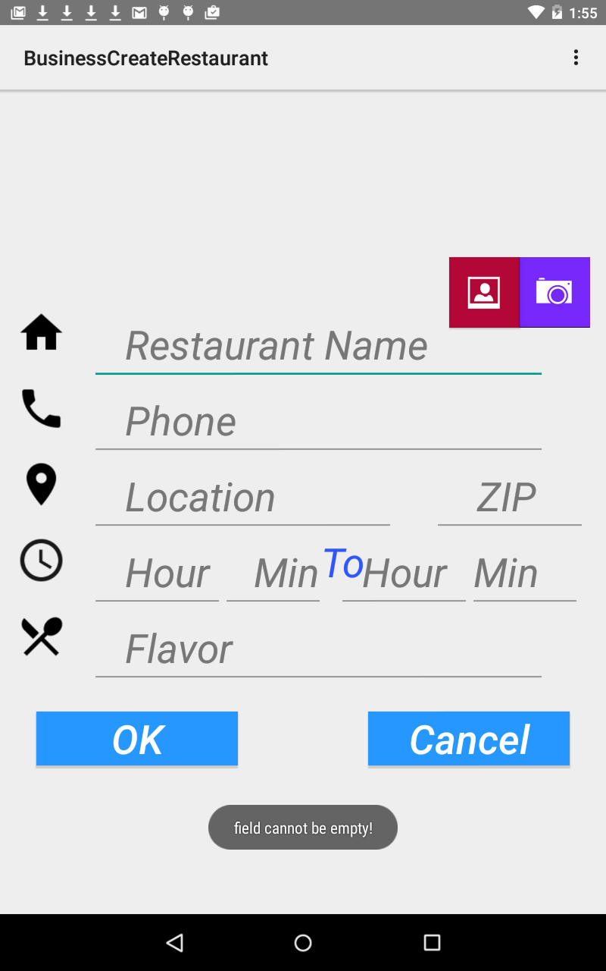

Also, when creating new restaurants, when entering open hour, the user can not enter invalid open hour time, such as enter an hour which is greater than 24 or min which is greater than 60.

